UI

🖥️ What is User Interface (UI)
# Source: AI Source: Provided by: [Data Path: Persons Table -> ID Column: 1, Name_En Column: Motasem Essam] -> From: [ChatGPT] on [1/23/2026]
The User Interface (UI) is the part of an application that users see and interact with. It’s the “face” of the software, connecting humans to the underlying functionality.
👉 Think of UI as the visual and interactive layer of your app — buttons, forms, menus, text, colors, and layouts.

🔑 Key Points About UI
# Source: AI Source: Provided by: [Data Path: Persons Table -> ID Column: 1, Name_En Column: Motasem Essam] -> From: [ChatGPT] on [1/23/2026]
- Displays information from the app (data, messages, errors).
- Receives input from the user (clicks, typing, gestures).
- Translates user actions into requests for the app to process.
- Should be intuitive, responsive, and visually consistent.
- Works closely with ViewModel or Controller to reflect UI state.

🧱 Examples of UI Elements
# Source: AI Source: Provided by: [Data Path: Persons Table -> ID Column: 1, Name_En Column: Motasem Essam] -> From: [ChatGPT] on [1/23/2026]
- Text and Labels → showing names, instructions, or messages
- Input Forms → text fields, checkboxes, radio buttons
- Buttons → trigger actions like “Submit” or “Delete”
- Menus and Navigation → allow moving between screens or pages
- Indicators → loading spinners, progress bars, or error messages

🔄 How UI Interacts in Architectural Patterns
# Source: AI Source: Provided by: [Data Path: Persons Table -> ID Column: 1, Name_En Column: Motasem Essam] -> From: [ChatGPT] on [1/23/2026]
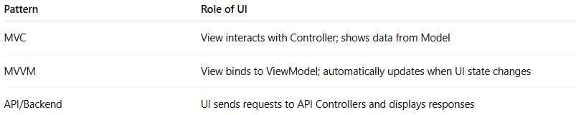
Pattern | Role of UI
MVC | View interacts with Controller; shows data from Model
MVVM | View binds to ViewModel; automatically updates when UI state changes
API/Backend | UI sends requests to API Controllers and displays responses

💡 Key Idea
# Source: AI Source: Provided by: [Data Path: Persons Table -> ID Column: 1, Name_En Column: Motasem Essam] -> From: [ChatGPT] on [1/23/2026]
UI is what users interact with, while the underlying state, logic, and data are handled separately to keep the app maintainable and testable.

🧾 Summary
# Source: AI Source: Provided by: [Data Path: Persons Table -> ID Column: 1, Name_En Column: Motasem Essam] -> From: [ChatGPT] on [1/23/2026]
- Provides visual representation of the application
- Receives input from users
- Reflects UI state and updates dynamically
- Works with Controller or ViewModel for clean separation

